**SponsorCoin: A Peer-To-Peer Electronic Sponsorship System**

**SponsorCoin: A Peer-to-Peer Electronic Sponsorship System**

Robert Lanson

[robert.Lanson@protonmail.com](mailto:robert.Lanson@protonmail.com)

[www.sponsorcoin.org](http://www.sponsorcoin.org)

**Abstract.** A purely peer-to-peer version of sponsorship crypto would allow online payments to be sent directly from one party to another without going through a financial institution. Financial Institutions while claiming to be secure are one of the least secure parties due partially to “Bail in Legal Tender Laws” and total disregard for privacy utilizing KYC and other protocol tracking implementations. We propose a solution where the free-market economy can donate sponsorCoin crypto coins while maintaining complete custody of any sponsorCoins obtained. This donation is an ongoing sponsorship implementation utilizing proof of stake and is only revoked when the coins are either removed from the sponsor’s wallet and returned to the market, or the sponsor reallocates the coins to a new sponsor. Newly allocated proof of stake coins will have a portion of these coins distributed to the sponsored recipient’s wallet with the remaining coins deposited in the sponsor’s wallet with the same proportional sponsor distribution. When a sponsor obtains sponsorCoins in their wallet, the sponsored recipient’s address may be provided. If no recipient address is provided, the recipient is deemed unallocated and the unallocated coins are returned to the sponsorCoin’s pool. SponsorCoins are proposed to have an annual ten percent inflation with a delegated allocation of no less than 2% delegated to the sponsored party and the remaining allocated to the sponsor.

# Introduction

Sponsorship on the Internet has come to rely almost exclusively on financial institutions serving as trusted third parties to process electronic payments. While the system works well enough for most transactions, it still suffers from the inherent weaknesses of the trust-based model. Completely non-reversible transactions are not possible since financial institutions cannot avoid mediating disputes. Outside influencers may also play a role of interference with the transaction through regulations and other mandates warranted or not. Transactions through a financial system always involves trust and trust is a potential point of failure. Middleman three-tiered financial transaction costs are substantially higher in fees and latency delays. Sponsored recipients must be constantly soliciting to ensure the flow of funds required for their cause. A certain percentage of fraud is accepted as unavoidable. These costs and payment uncertainties can be avoided in person by using physical currency, but no mechanism exists to make payments over a communications channel without a trusted third party. Finally current sponsorship systems involve the alleviation of capital from the sponsor which is a limiting factor on contributions collected for the cause.

What is needed is an electronic payment system based on proof of stake instead of trust, allowing any two willing parties to transact directly with each other without the need for a trusted third party. Transactions that are computationally impractical to reverse would protect sponsors from fraud and other outside interferences. Newly routinely generated coins through proof of stake would be distributed proportionally between the sponsor and the sponsored recipient. This form of sponsorship would ensure a constant funding supply to the sponsor and sponsored recipient. In this paper, we propose a solution to the inefficiency of the current sponsorship systems while providing a constant flow of capitol to both the sponsor and sponsor recipient.

# Technology

The initial release of sponsorCoin is a blockchain Layer 2 solution written in the solidity language deployed on a Layer 1 block chain such as Ethereum, Binance, Fantom, Solarium and others. Web 3 is utilized for transactional processing along with front end framework tools and other technologies. The sponsorship coins can be managed through layer one custodian wallets; however, a sponsorship management wallet app with management contracts are required to allocate and re-allocate the sponsors proportions.

# Transactions

Like all layer 2 token transactions, each wallet owner acquires sponsorCoins into their wallet digitally through the acquisition of coins from an alternate layer 1 network such as Ethereum. Other market traded coins can be used for acquiring the specified amount of sponsorCoins using atomic swaps. SponsorCoins may be bought from supporting exchanges or directly through web sponsor recipients using a custom sponsorCoin page. A fictious Sponsors recipient “Sick Kids Hospital”, Page would Contain a dialogue like follows:

**Sample SponsorCoin Recipient Page.**

**Buy your Sick Kids Hospital sponsorCoins Here**

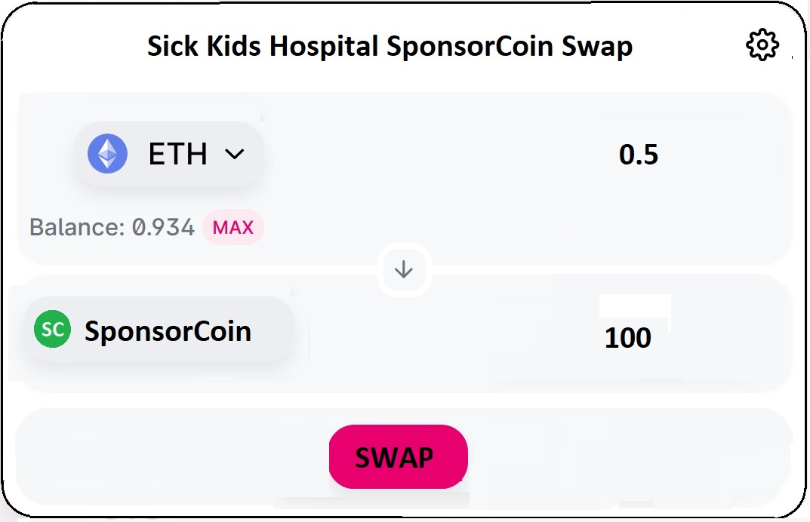

**Image 1 (Recipient Page)**

Upon Loading this page, the gear configurator above can be allowed to connect to a wallet such as Metamask.

The Selected coin in this case Ethereum would be matched with the market value of SponsorCoin at the time of trade. When swap button is selected, the desired amount is deposited to the sponsor’s wallet account and these sponsorCoins will be linked to the sponsored recipient. The sponsor and the sponsored recipient will share a percentage of future proof-of-stake distributions from the sponsorCoins staking pool in proportion to the amount of sponsor coins bought by the sponsor. In this regard, both the sponsor and recipient are benefiting from the transaction.

The Swap Button executes a sponsorCoin contract which exchanges the payment token with the amount of sponsorCoins purchased. The sponsored coins are deposited into the sponsor’s wallet along with the sponsor recipient’s “Registered Name” or “Wallet Address”. If a recipient’s name or address is not provided, then the coin will be deposited to the wallet with the recipient deemed as unallocated.

Coins in the sponsor’s wallet are managed through a sponsorCoin management app. This app connects to a remote wallet such as Metamask through the configuration gear in the top right-hand corner. Other configurations such as user Id and password settings are also administered here. The configuration gear on the right of every sponsored recipient is used to reallocate or unallocated sponsorships. *

**Sample SponsorCoin Sponsor Page.**

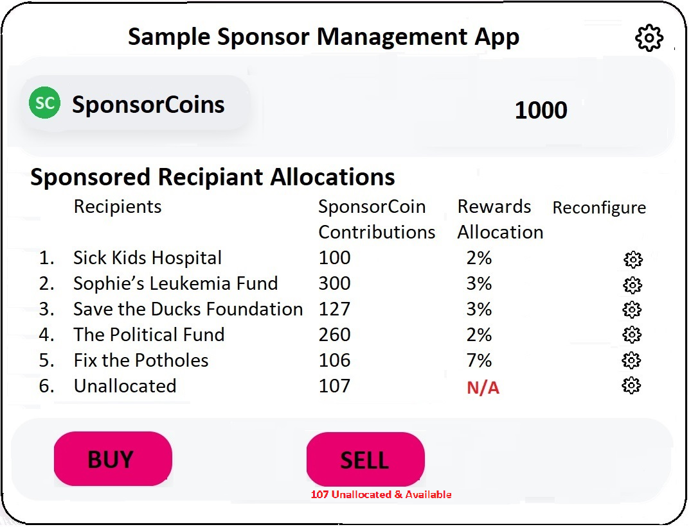

The Buy button executes a contract to buy directly from an exchange through a third-party app like Metamask.

The Sell button executes a contract to sell back to the exchange through a third party app like Metamask. *

**\* Note:** Only coins which are unallocated may be returned to the market. In the GUI example above, we can see that 107 coins are unallocated and ready to be sold back to the market.

# Proof of Stake Distribution Allocations

SponsorCoins are proposed to have an annual ten percent (10%) inflation with a allocation of no less than 2% delegated to the sponsored party and the remaining allocated back to the sponsor. If a sponsor’s recipient is assigned two percent (2%) then the remaining eight percent (8%) shall be deposited back to the sponsor’s wallet. These new proof of stake coins shall have the same proportional sponsor distribution allocation of two percent (2%) allocated to the recipient.

**\* Note:** The proportion of coins allocated to the recipient cannot be larger than the annual proof of stake distribution, in this case ten percent (10%).

SponsorCoin proof-of-stake distributions can be expected at a minimum daily distribution rate. The interest rates calculations per distribution cycle is calculated as:

Annual Interest Rate

--------------------------------------------

(Number of annual distributions)

Example: A daily distribution at an annual rate of ten percent (10%) can be calculated as

10% 0.0273785%

------ = ----------------

365.25 (Days in year) Day

Example: If a sponsor allocates two percent (2%) from the ten percent (10%) to a given recipient, then the remaining eight percent (8%) shall be deposited in the sponsor’s wallet.

## **Proof of stake proposed allocation rules:**

* The annual proof of stake inflation is assumed to be set at ten percent (10%)
* The minimum of sponsor is to be two percent (2%)
* The proportion of coins allocated to the recipient cannot be larger than the annual proof of stake distribution, in this case ten percent (10%).
* The sponsor’s wallet address and the recipient’s wallet address cannot be the same, that is you cannot sponsor yourself to collect staking rewards.
* The sponsors proof of stake is calculated as (10% - Recipients) percent allocation.
* If you do allocate a sponsor for your sponsorCoins, that is the coins are unallocated, then no proof-of-stake distribution shall be awarded for either the sponsor or recipient and the sponsorCoins shall not be distributed from the sponsorCoin foundation.

# Wallets

**The Sponsor Recipient Wallet**

Anyone can become a sponsor recipient since any custodial wallet such as Ledger or metamask can be used to store sponsorCoins. What is required is a level 1 address on a block chain such as Ethereum along with a wallet such as Metamask to buy and sell. Once an address is obtained the user can buy and sell sponsorCoins just like any other token.

To raise capitol from other sources, a web page on the sponsor’s site is required for sponsors to buy coins from the recipient’s page. When the coins are purchased off of the recepients page, these coins will be sent to the sponsors wallet with a portion of the proof-of-stake generated coins allocated to the recipient’s wallet.

The web page, (See **Image 1 “Recipient Page”** Above), is a simple setup and can be downloaded from sponsorCoins foundation site. Once downloaded, a small configuration program is run to customize the recipient’s page which will rename the sponsorCoins page and set the recipients address for every purchase through this GUI.

# Incentive

The incentive for sponsorCoin market participation is built on a symbiotic relationship between the sponsor and recipient. There have always been cause for charity, but the benefits of sponsorCoin far outweighs traditional markets.

**The Recipient**

Traditionally the recipient has always had to constantly solicit funds for its cause. This has always been a constant and expensive way of doing business with a great deal of accounting and fees required for fund raisers. This money could be better used for the cause at hand Accounting is simplified by tallying the sponsorCoins while mitigating administration expenses. Because there is no direct out of pocket money from the sponsor, the contributions may be considerably higher through higher sponsorCoin accumulations

**The Sponsor**

This is the first known program where the sponsor never directly funds a cause and hence there is no direct alleviation of capitol from the sponsor. All that is required is that the sponsor purchase coins from of a recipient’s site. That is it! For as long as the sponsor holds the coins for a given beneficiary, the recipient’s cause will consistently be funded, and the sponsor will also receive sponsor coins as an additional incentive.

# Risk

There is no inherent risk to either party outside of negligent management practices and/or poor security. This is not however protocol risk, but rather in house risk. The protocol itself is reliant on the internet and the Level 1 host security as well as the actual sponsorCoin contracts. As in any market, there are market risks when venturing into any market driven protocol based on demand and supply.

**In House Security**

Hacking has always been a problem, not just in the Crypto market but also for the computer market in general. Properly managed in house security implies proper security such as offline cold storage or paper wallets. Wallets which are online should have proper key management security. Another form of contention involves third party exchanges since this involves handing over your keys. As is well known in the industry, “Not your Keys, Not your Coins”. So it is always advise to keep your keys in house.

**Reliance Risks**

SponsorCoin like all cryptos is reliant on internet access. Without the internet, for the most part, you are left with nothing. Likewise, Level 2 crypto tokens are totally reliant on level 1 protocols such as Ethereum to be constantly available. Should either of these reliance factors fail, the system fails and there is much worse ramifications than just the sponsorCoin token.

**SponsorCoin Protocol Contract Risks**

SponsorCoins protocol contracts are fully audited so that risks are alleviated. Additionally, the sponsorCoin foundation will maintain a constant offline supply of sponsorCoins to prevent unauthorized access.

**Market Risks**

Market risks are inherent with any market traded entity. Value is determined on supply and demands.

Working Here

# Privacy

ToDo

# Conclusion

ToDo

Recipients SponsorCoin Rewards

Contributions Allocation

1. Sick Kids Hospital 100 2%
2. Sophie’s Leukemia Fund 300 3%
3. Save the Ducks Foundation 127 3%
4. The Political Fund 260 2%
5. Fix the Potholes 106 7%
6. Unallocated 107 N/A